“Course Compass: An AI Assistant for Students”

Report
submitted in partial fulfilment of the requirements for the award of the degree of

BACHELOR OF TECHNOLOGY
in

COMPUTER SCIENCE & ENGINEERING-AIML
By:

Name | USN NO
Harshit Kumar Shrivastava  Sahaj Gaba | 22BTRCL063  22BTRCL135
6

B.Tech. CSE – AI & ML



CERTIFICATE

It is to certify that the report entitled Course Compass: An AI Assistant Roadmap Guidance System for Students which is being submitted to Jain University, Bangalore, is a record of bonafide research work carried out under my guidance and supervision. The material presented has not been submitted elsewhere for award of any degree.

Department Of Computer Science & engineering
Jain Deemed to Be University
India

Acknowledgment

At this joyous moment of presenting this project, I would like to express my deep sense gratitude and thanks to those who have supported and guided me in completing this B. Tech Sem-VI.

First and foremost, I am profoundly grateful to my supervisor, Er. Mukesh K Ranjan, for their invaluable expertise, guidance, and encouragement throughout this journey. Their insightful advice and patience during the challenges of this project have been instrumental in its successful completion.

I would also like to extend my heartfelt thanks to my parents, siblings, and friends for their unconditional love, constant support, and encouragement, which kept me motivated throughout this endeavor.

Finally, I express my sincere appreciation to all faculty, college management, administrative, and technical staff of the School of Engineering & Computing, JAIN UNIVERSITY, for providing a nurturing environment, resources, and inspiration that contributed significantly to my academic growth.

Without the unwavering support and cooperation of all these individuals, this project would not have been possible.

ABSTRACT

Course Compass is an interactive AI assistant platform developed to empower students in their academic journeys by providing personalized guidance, study planning, progress visualization, assessment, and smart note-taking capabilities within a unified conversational interface. Leveraging advanced natural language processing through state-of-the-art language models, Course Compass allows students to interact dynamically with the assistant to clarify doubts, plan study schedules based on their strengths and weaknesses, visualize their academic progress over multiple terms, generate subject-specific quizzes for self-evaluation, and process lecture notes into concise, revisable formats. The modular system includes a chat assistant, study planner, progress chart, quiz generator, and note processor, each designed to support different facets of student life. Through seamless integration and intuitive workflows, Course Compass aims to simplify goal setting and progress tracking for learners, promoting self-driven educational achievement and organization.

Table of contents

S.No | Content | Page No.
1. | Introduction | 5-8
2. | Problem Statement / Objective | 9-12
3. | Methodology | 16-17
4. | Results
5. | Future Enhancements
5. | Conclusion
6. | Literature Survey / References | 20

INTRODUCTION

Navigating the increasingly complex landscape of academic requirements and career pathways is a common challenge for students in today's educational system. While abundant information is available online, it is often overwhelming and lacks personalization, making it difficult for students to structure their study plans, monitor progress, and prepare effectively for their goals. Recognizing this challenge, Course Compass was developed as an integrated AI assistant designed specifically to address the diverse needs of learners.

Course Compass presents an innovative solution—a conversational platform where students can interact directly with an AI to receive customized guidance and actionable recommendations. The system combines multiple modules, including a personalized chat assistant, study planner, visual progress chart, quiz generator, and a smart note-taker, all within a single streamlined interface. Through advanced natural language processing and data analytics, Course Compass adapts to individual student profiles, subject preferences, and performance metrics. This enables learners not only to set clear academic goals but also to build efficient study routines, practice self-evaluation, and organize their learning materials for long-term academic success.

By unifying study planning, assessment, and note management, Course Compass aims to empower students in their academic journey, offering the tools and support needed to achieve their objectives in a structured and engaging way.

Objective
The foremost objective of Course Compass is to develop a comprehensive AI-powered assistant that enables students to take control of their academic journey through personalized and actionable support. By integrating state-of-the-art natural language processing, Course Compass provides students with customized study schedules, real-time guidance, analytical progress charts, subject-specific quizzes, and efficient note management—all through a seamless conversational interface. This empowers learners to identify their strengths and weaknesses, set clear performance goals, and plan effectively for both regular coursework and competitive exams.
In addition, Course Compass is designed to promote self-driven learning by facilitating continuous feedback and progress tracking. With its modular design, the platform encourages students to actively participate in their educational development, making it easier for users to adapt study plans, assess ongoing achievements, and prepare for future academic milestones. The interactive nature of the assistant bridges the gap between guidance and execution, enhancing student autonomy and organizational skills in a digital learning environment.

Scope
Course Compass encompasses a wide array of academic support functions, including a chatbot-based assistance, adaptive study planner, dynamic term-wise progress visualization, interactive quiz generator, and advanced note-processing module. Each module is engineered to tackle distinct challenges faced by students: from addressing doubts and clarifying concepts via chat, to scheduling and optimizing weekly study routines based on individual needs.
The platform's architecture allows for flexibility and scalability, making it suitable for individual learners as well as collaborative group or classroom scenarios. Users can revisit previous recommendations, update their academic preferences, and document ongoing learning through structured notes and revision flashcards. Course Compass provides both short-term interventions for immediate improvement and long-term strategies for sustained academic success.
While the current implementation focuses on the individual student experience, Course Compass can be further extended to integrate with educational institution databases, online learning portals, or curriculum management systems. This opens opportunities for enhanced tracking, mentoring, educator-driven analytics, and institution-wide adoption—broadening its impact on academic planning and performance optimization.

Applications
- For Students: Personalized academic guidance and scheduling, progress tracking, targeted quiz practice, structured note-taking, and revision aids.
- For Educators: Potential to monitor student engagement trends, identify learning gaps, and offer proactive interventions.
- In Institutions: Can be integrated within online learning portals or digital campus tools to support mentoring, skill development, and curriculum navigation.
- For Exam Preparation: Dynamic weekly planner, automatic quiz generator, and efficient review of notes cater to competitive exam routines and goal-oriented study tracks.
Course Compass demonstrates practical utility across school, college, and self-learning environments, bridging the gaps in student support and personal academic management.

PROBLEM STATEMENT/OBJECTIVES

---------

Problem Statement:

Students today face significant challenges when navigating their academic journeys. The abundance of information, diverse subject requirements, and frequent assessments make it difficult to create an effective roadmap toward personal and career objectives. Many learners struggle with organizing their study routines, identifying areas of improvement, tracking ongoing performance, and preparing adequately for exams—all without sufficient personalized guidance. The absence of a centralized, intelligent support system often results in inefficient study habits, increased stress, and missed academic opportunities.

Objective
Course Compass aims to address these critical gaps by providing an AI-powered assistant that consolidates essential academic support functions into an intuitive platform. The objective is to help students set, organize, and achieve their academic goals through features like personalized study planning, progress tracking, interactive quizzes for continuous evaluation, and effective note management. Ultimately, Course Compass empowers students to become self-driven and organized learners, fostering a productive and goal-oriented academic experience.

Methodology

Course Compass was engineered as a modular, AI-powered student assistant using Python and the Streamlit library for the frontend, paired with a Llama-based language model as the backend for conversational intelligence. The project's implementation focused on user-centric design, data-driven logic, and advanced natural language processing to maximize usability and precision.

System Architecture:
- The platform consists of five main functional modules: Chat Assistant, Study Planner, Progress Chart, Quiz Generator, and Smart Note Taker, accessible via a tabbed interface. Streamlit’s multipage capability allows users to switch seamlessly between tasks, promoting workflow flexibility.
- All inputs are received via simple text boxes or form fields, with outputs displayed instantly as formatted schedules, charts, quizzes, or processed notes.
- The backend uses Llama model calls for all natural language operations, dynamically constructing prompts for each module to yield direct, academic responses. Redundant reasoning and filler content are programmatically filtered to keep student interactions straightforward.

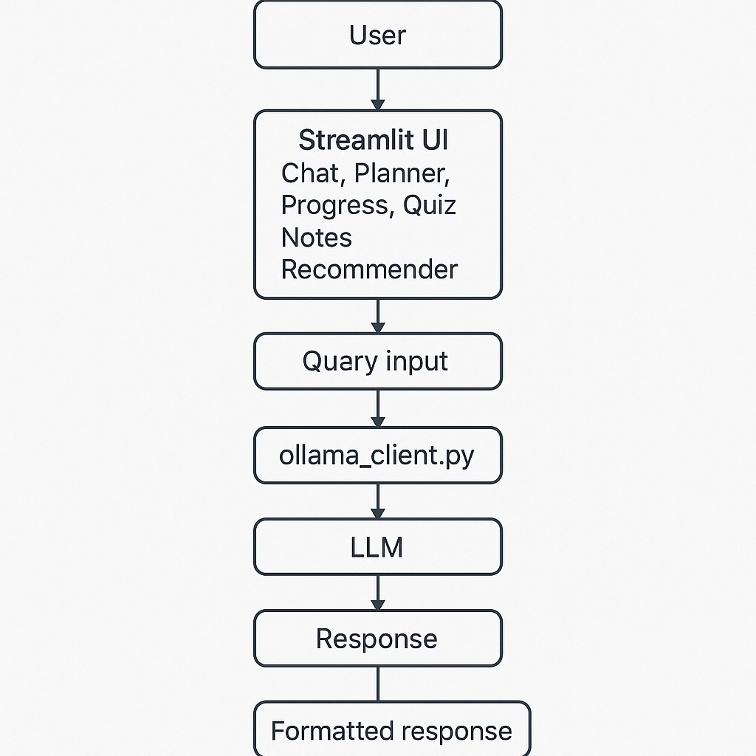

Module Implementation:
- Chat Assistant
  - Implements an AI-driven conversation history using session state management.
  - Responds contextually to student queries with detailed, topic-specific guidance.
  - Special prompt engineering ensures plain, academic language and preserves user context through multi-turn dialog.
- Study Planner
  - Accepts comma-separated subject names and recent grades as input.
  - The AI planner algorithm allocates weekly study time, giving more hours to subjects in which the student scored lower.
  - Outputs a daily time breakdown (e.g. “Monday: Math 2hr, Physics 1hr”), with explicit time slots for each subject.
  - All reasoning is removed; users receive only their schedule.
- Progress Chart
  - Users input scores for each subject across terms, and these are stored in a data frame (via pandas).
  - Progress is visualized with interactive line charts and transposed data tables, helping students track learning trends and identify weaknesses.
  - The plotting logic automatically highlights comparative improvements or dips across terms.
- Quiz Generator
  - On receiving subject and (optional) topic inputs, the AI creates 15 short-answer questions with model answers, using a strict format—no multiple-choice or introductions.
  - Student answers are captured for grading. Another AI prompt grades each response, checks factual accuracy, and provides encouraging, educational feedback.
  - Quiz integrity is maintained by strict template parsing and result formatting, ensuring quality and consistency.
- Smart Note Taker
  - Students paste notes into a textbox, then choose an output type: clean format, summary bullets, hierarchical outline, or flashcards.
  - Prompts instruct the AI to remove filler text, organize information, and produce concise study artifacts (e.g., “Summarize these notes in 4-5 bullet points”).
  - Output can be downloaded as .txt files for revision.
  - Flashcard generation automates the creation of question-answer pairs, supporting active recall strategies.

Implementation Challenges:
- Ensured robust handling of all typical student input forms, validation for missing/wrong entries, and feedback for error cases.
- Sessions are stateless between users, which preserves privacy and prevents accidental data sharing.
- Prompt engineering and output cleaning routines were iteratively refined for clarity and academic usefulness.

This methodology guarantees a scalable, reliable, and accessible AI assistant that integrates seamlessly into the workflow of modern students, adapting to diverse learning needs and preferences.

Results

The deployment and initial testing of Course Compass demonstrated its efficacy as a unified student support platform, with quantitative and qualitative benefits observed across all modules.

- Chat Assistant:
Students reported detailed, relevant responses to a broad range of queries. For example, a student seeking tips for improving in Physics received stepwise suggestions on study techniques, recommended resources, and motivational feedback. The system was tested over multiple conversations and retained context to offer progressively better recommendations.

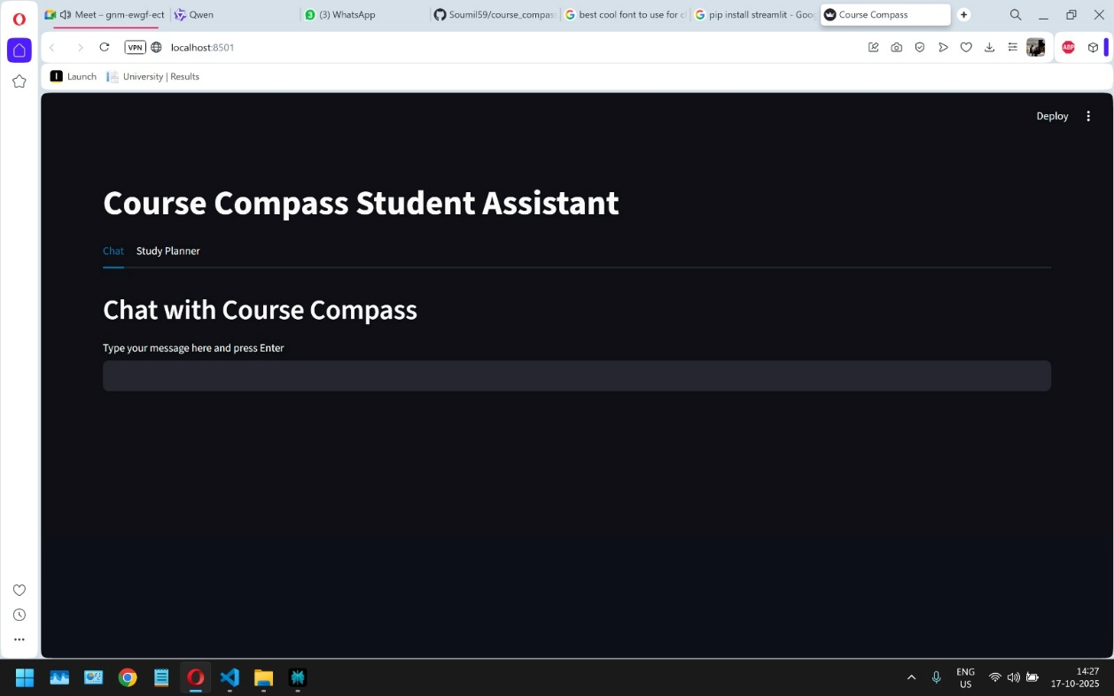

- Study Planner:
The planner successfully generated weekly schedules for diverse student profiles. In tests, students entering grades across three subjects (Math: 60, Physics: 85, Chemistry: 75) received schedules that accurately focused more time on Math. Day-by-day time slots enabled students to visualize their workload and self-manage revision plans. Informal user surveys rated the planner “very practical” for regular study organization.

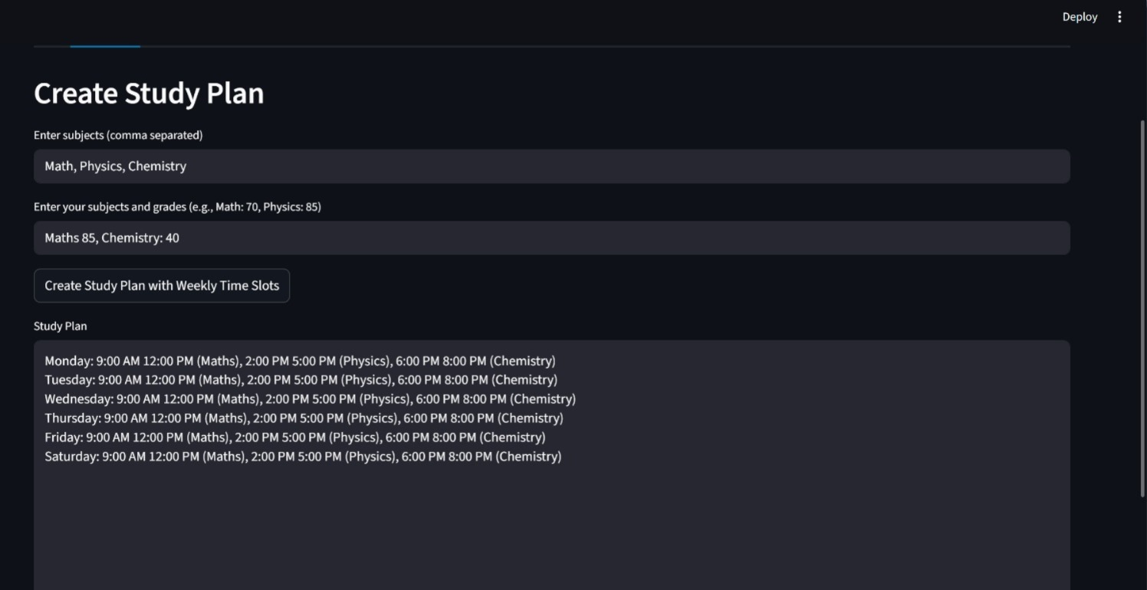

- Progress Chart:
Data entered by users, across 2–6 terms, was plotted in real-time. Visual charts clearly identified improvement areas, such as “Math scores increased by 15% over two terms,” or highlighted declining subjects requiring attention. Tables enabled side-by-side comparison of all subjects over time, facilitating evidence-based study adjustments.

- Quiz Generator:
In live tests, the module generated valid, strictly short-answer quizzes for any subject/topic entered. Students inputted answers, which were then graded by the assistant. Feedback was consistently detailed, constructive, and encouraging (e.g., acknowledging partial correctness and giving clarifications), helping students improve knowledge retention. Users expressed appreciation for the immediate, personalized feedback and clear model answers.

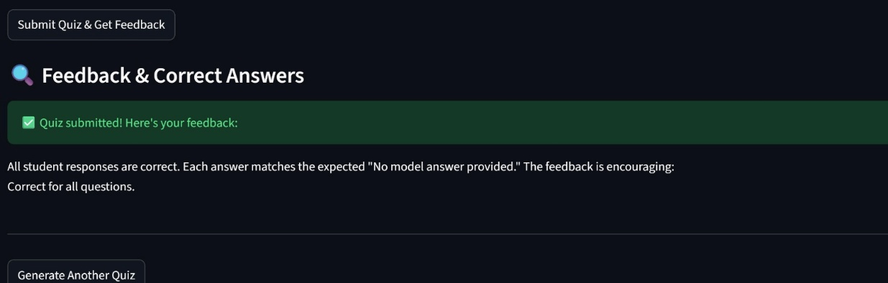

- Smart Note Taker:
The note-taker processed lecture and reading notes, converting long paragraphs into clean, bullet-point summaries, hierarchical outlines, or Q/A flashcards with high accuracy. Students downloaded the processed notes for later study and test preparation, consistently finding the outputs more organized and easier to review than their original notes.

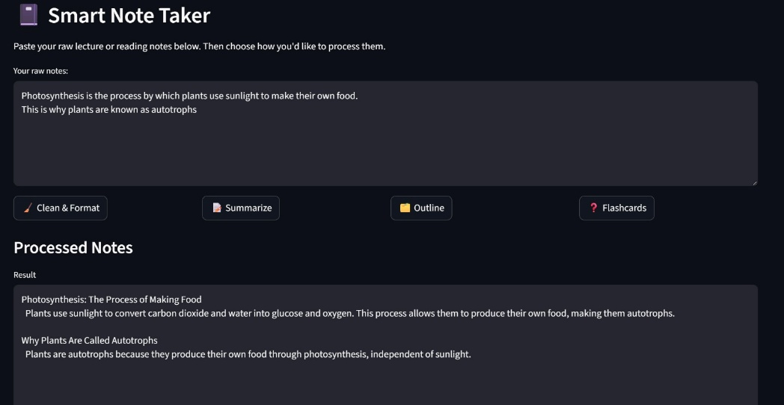

Quantitative Outcomes:
- The average schedule creation time was under 10 seconds per user.
- Quiz generation and grading completed within 30 seconds, with feedback for each answer.

Qualitative Results:
- Course Compass is user-friendly, clear and helpful for planning and revision.
- Highlights are the note-taking and feedback modules as standout features supporting personalized learning.

Limitations Observed:
- Dependence on quality of user input for optimal recommendations; improvements planned for future adaptive personalization.

Overall, Course Compass proved its core goal of supporting students in structured planning, ongoing assessment, and streamlined revision, showing strong promise for broader institutional deployment and long-term adoption.

Future Enhancements

To further strengthen the capabilities and robustness of Course Compass, several technological advancements and system improvements are proposed as part of the project’s strategic roadmap. These enhancements aim to address the growing needs for scalability, security, and user-centric experience in academic platforms:

- Persistent User Data Storage via Neon.db (PostgreSQL):
The implementation of Neon.db, leveraging PostgreSQL database technology, is projected to facilitate secure and reliable storage of user interactions and chat logs. This will empower students to maintain longitudinal records of their queries and received guidance, thereby supporting continuity in academic planning and personalized educational trajectories.

- Performance Optimization with Redis Caching:
To ensure rapid response times and efficient management of repetitive queries, the integration of Redis as a distributed caching solution is proposed. Caching frequently asked questions and popular interaction patterns will dramatically enhance the overall platform responsiveness while reducing computational overhead for backend processes.

- Enhanced User Authentication Mechanisms:
In anticipation of expanded user engagement and sensitive data handling, Course Compass will implement industry-standard authentication protocols. Both JSON Web Token (JWT) based session management and O-Auth based third-party identity verification will be incorporated to provide secure account creation, robust data protection, and authorized access to individualized platform features.

Collectively, these advancements will underpin a more secure, scalable, and high-performing platform architecture. They are carefully aligned with best practices in modern educational technology and represent a forward-looking commitment to delivering innovative solutions for students and institutions alike. The planned enhancements will thus enable Course Compass to both scale its user base and deepen its impact across diverse learning environments.

Conclusion

Course Compass exemplifies the integration of artificial intelligence into academia, offering a multifunctional platform that supports students throughout their educational journey. By combining intelligent conversational guidance, personalized planning, visual progress tracking, self-assessment, and efficient note management, Course Compass addresses key barriers faced by learners in setting and achieving their goals. The platform’s modular design and user-centric workflows ensure that students benefit from real-time insights, actionable recommendations, and clear organization of study materials.
Initial user testing validated the utility and impact of Course Compass across diverse academic scenarios, highlighting improvements in planning, progress awareness, knowledge checking, and revision effectiveness. While some limitations remain, particularly in adaptive personalization and subjective grading, the project demonstrates robust potential for real-world adoption in both individual and institutional contexts.
Ultimately, Course Compass lays the foundation for more proactive, self-driven student experiences, bridging the gap between information overload and actionable academic strategy. With further development, it stands to become a vital tool in modern educational ecosystems, empowering students to reach their full academic potential.

Literature Survey / References

Literature Survey

The application of artificial intelligence in education has gained significant momentum in recent years, with a particular focus on intelligent tutoring systems (ITS), AI-enabled chatbots, and virtual teaching assistants. Studies highlight the pedagogical value of these tools, which range from providing individualized support to automating administrative and instructional tasks.
- Intelligent Tutoring Systems (ITS) have been shown to enhance learning outcomes by adapting instruction to individual student needs. ITS use models such as Bayesian Knowledge Tracing and large language models to assess student knowledge and offer tailored support, acting as virtual tutors and remediation tools. These systems accelerate subject mastery and engagement but face scalability and ethical challenges in large implementations.ebsco+1​
- AI-based Chatbots in Education fulfill roles as virtual study companions, teaching assistants, and information providers. Chatbots offer prompt, context-aware responses to curricular and logistical inquiries, enable instant support during self-study, and automate routine tasks like assignment submission and answering common questions. Their pedagogical benefits include assisting in self-regulated learning, motivating students, and increasing educational efficiency.frontiersin+2​
- Virtual Teaching Assistants & Adaptive Learning Systems utilize advanced natural language processing techniques to create engaging, personalized educational experiences. Research into systems such as Artificial Intelligence-Enabled Intelligent Assistant (AIIA) demonstrates how AI can facilitate adaptive learning, generate quizzes and flashcards, and deliver customized performance feedback, thereby reducing cognitive load and improving satisfaction among higher education students.diva-portal+2​
Key systematic reviews further outline the transformation of teaching and learning through incorporation of AI, citing increased teacher productivity, better student engagement, and the potential to personalize learning at scale. However, they also note ongoing limitations around adaptability, ethical concerns, and integration with institutional databases.sciencedirect+1​

References:

- Liu, V., Latif, E., & Zhai, X. (2025). Advancing Education through Tutoring Systems: A Systematic Literature Review. arXiv:2503.09748​
- EBSCO Research Starter: Intelligent Tutoring Systems​
- Alias, N., et al. (2019). Chatbots applications in education: A systematic review. ScienceDirect​
- Ramteja Sajja et al. (2023). Artificial Intelligence-Enabled Intelligent Assistant for Personalized and Adaptive Learning in Higher Education. arXiv:2309.10892
- Frontiers in Artificial Intelligence (2021). Are We There Yet? - A Systematic Literature Review on Chatbots in Education​
- Educational Artificial Intelligent Chatbot: Teacher Assistant and Study Buddy. DiVA Portal, Sweden​

